Hartley Oscillator
Hartley Oscillator is a type of Tuned Circuit Oscillators which are used to produce the waves in the range of radio frequency and hence are also referred to as RF Oscillators. Its frequency of oscillation is decided by its tank circuit which has a capacitor connected in parallel with the two serially connected inductors, as shown by Figure 1.
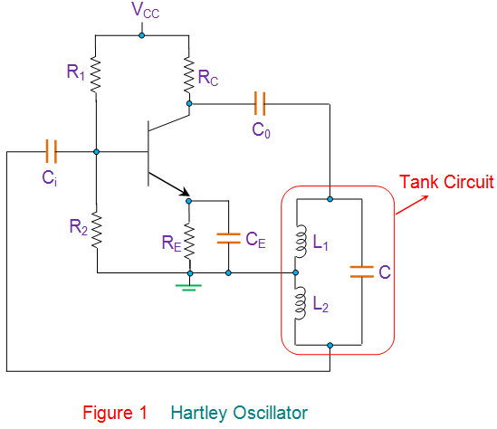
Here the R_{C} is the collector resistor while the emitter resistor R_{E} forms the stabilizing network. Further the resistors R₁ and R₂ form the voltage divider bias network for the transistor in common-emitter CE configuration. Next, the capacitors C_{i} and C_{o} are the input and output decoupling capacitors while the emitter capacitor C_{E} is the bypass capacitor used to bypass the amplified AC signals. All these components are identical to those present in the case of a common-emitter amplifier which is biased using a voltage divider network. However, Figure 1 also shows one more set of components viz., the inductors L₁ and L₂ and the capacitor C which form the tank circuit (shown in red enclosure).
On switching ON the power supply, the transistor starts to conduct, leading to an increase in the collector current, I_{C} which charges the capacitor C. On acquiring the maximum charge feasible, C starts to discharge via the inductors L₁ and L₂. This charging and discharging cycles result in the damped oscillations in the tank circuit. The oscillation current in the tank circuit produces an AC voltage across the inductors L₁ and L₂ which are out of phase by 180º as their point of contact is grounded.
Further from the figure, it is evident that the output of the amplifier is applied across the inductor L₁ while the feedback voltage drawn across L₂ is applied to the base of the transistor. Thus one can conclude that the output of the amplifier is in-phase with the tank circuit’s voltage and supplies back the energy lost by it while the energy fed back to amplifier circuit will be out-of-phase by 180º. The feedback voltage which is already 180º out-of-phase with the transistor is provided by an additional 180º phase-shift due to the transistor action. Hence the signal which appears at the transistor’s output will be amplified and will have a net phase-shift of 360º.
At this state, if one makes the gain of the circuit to be slightly greater than the feedback ratio given by
$β= L_{2 }$/$L_{1}$ (if the coils are wound on different core)
$β=(L_{2 }+M)$/$(L_{1}+M)$
(if the coils are wound on the same core with M indicating the mutual inductance)
Also since A$β ≥1 so A$≥ $L_{1 }$/$L_{2}$
Then the circuit generates the oscillations which can be sustained by maintaining the gain of the circuit to be equal to that of the feedback ratio. This causes the circuit in Figure 1 to act as an oscillator as it would then satisfy both the conditions of the Barkhausen criteria.
The frequency of such an oscillator is given as
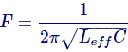
Where;
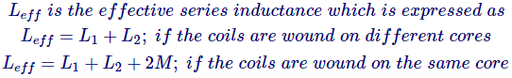
Hartley Oscillators are advantageous as they are easy-tunable circuits with a very few components including a capacitor and either two inductors or a tapped coil. This result in a constant amplitude output throughout its wide operational frequency range which typically ranges from 20 KHz to 30 MHz However, this kind of oscillator is not suitable for low frequency as it would result in a large-sized inductor which makes the circuit bulky. Further, the output of Hartley Oscillator has high content of harmonics in it and hence does not suit for the applications which require pure sine wave.

Want More Electrical Knowledge?
Enter your email below to receive FREE informative articles on Electrical & Electronics Engineering

